21st August 2015.

To: Each Member of the Joint Policing Committee.

Re: Meeting of the Joint Policing Committee

Dear Member,

I wish to inform you that the next meeting of the Joint Policing Committee will take place in the Council Chamber, Aras an Chontae, Great Water Street, Longford, on Friday, 11th September 2015 at 11.00 a.m. to transact business, as set out on the Agenda hereunder.

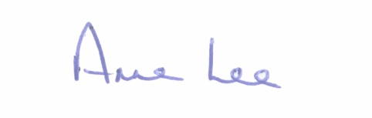
Yours sincerely,

___________________
Anne Lee,
Administrative Officer.

AGENDA

1. Confirmation of Minutes of Joint Policing Committee meeting held on the
12th June - copy attached.
2. Matters arising.
3. Garda Presentation.
4. Local Authority Presentation.
5. Anti-social behaviour.
6. Crimestoppers Initiative
7. CCTV
8. A.O.B.
9. Date of next meeting.

